SIMATS ENGINEERING (SAVEETHA SCHOOL OF ENGINEERING)
Department of Computer Science and Engineering
CO1_AT3 — VISUALIZATION DESIGN EXERCISE

Course Code: | DSA06 | Course Title: | Data Handling and Visualization
CO Assessed: | CO1 – Precision (BL2) | Assessment: | Assessment Tool 3 – Visualization Design
Weightage: | 40% of CIA | Total Marks: | 20 (2 Questions × 10 Marks)
CO1 Statement: | Understand the fundamental concepts, principles, and techniques of data visualization.(BL2)
Student Name: | Haritha S | Reg. No.: | 192324299
Section / Batch: | B.tech – AI&DS | Date: | 28/07/2026

Code of Conduct
I __________________________ (Name / Reg No) certify that this submission is my original work and that I have adhered to the guidelines specified for this assessment. I understand that any violation of academic integrity rules will result in disciplinary action.

Signature of the Student: _________________________

Instructions
- This assessment contains 2 questions, each carrying 10 marks. Total: 20 Marks.
- No negative marking. Unanswered questions carry zero marks.
- No calculators or electronic devices permitted.
- Duration: 60 minutes.

Annexure A – VISUALIZATION DESIGN

ASSESSMENT RUBRIC
AT3 — Visualization Design Exercise
CO1 · BT3: Apply ·
This rubric is used to assess student responses to the AT3 Visualization Design Exercise problems, in which students design and justify a complete visualization (chart type, aesthetic mappings, scales, coordinate systems, and/or color scheme) for a given dataset or design brief.

Criteria | Weightage | Level 4 – Exemplary | Level 3 – Proficient | Level 2 – Developing | Level 1 – Beginning
Understanding of Concepts | 25% | Demonstrates thorough, accurate understanding of chart types, aesthetic mappings, scales, coordinate systems, and color scales, and correctly identifies which apply to the given design scenario. | Good understanding of the relevant design concepts, with only minor gaps in selecting appropriate chart types, aesthetic mappings, or scales. | Basic understanding of design concepts, but with some misconceptions about appropriate chart types, aesthetics, or scales for the scenario. | Poor understanding of core design concepts; proposes chart types or mappings that are fundamentally unsuited to the data.
Explanation | 25% | Provides detailed, well-reasoned justification for every design decision, explicitly connecting each choice to the properties of the data and the scenario. | Provides clear justification for design decisions, with adequate reasoning for most sub-questions. | Justification is limited or superficial; design choices are stated without sufficient reasoning. | Little or no justification provided; design choices appear arbitrary or unexplained.
Application | 20% | Effectively applies visualization design principles to produce a complete, appropriate, and well-reasoned design solution for the specific scenario. | Applies design principles to produce an appropriate solution, with only minor errors or missed refinements. | Limited application of design principles; the proposed design partially addresses the scenario but has notable weaknesses. | Fails to apply appropriate design principles; the proposed design does not suit the scenario or data.
Organization | 15% | The design proposal is clearly structured, addressing each sub-question (a, b, c) in a logical sequence with coherent flow throughout. | The proposal is organized and addresses each sub-question, with only minor issues in flow or clarity. | Basic structure; sub-questions are addressed but the proposal lacks clarity or a logical sequence. | Poorly organized; the proposal is incoherent, and sub-questions are left unaddressed or answered out of order.
Accuracy | 10% | All design choices — chart type, aesthetic mapping, scale, coordinate system, and/or color scheme — are completely accurate and well-suited to the data. | Mostly accurate design choices, with only minor omissions or a small error in one part of the proposal. | Partially correct; some design elements are missing, mismatched to the data, or incorrect. | Design choices are largely incorrect or inappropriate, with major gaps in matching the visualization to the data.

Scoring Guide
For each criterion, award a performance level (1–4) based on the descriptors above. Multiply the level achieved (as a percentage of 4, i.e., Level 4 = 100%, Level 3 = 75%, Level 2 = 50%, Level 1 = 25%) by the criterion's weightage, then sum across all five criteria to obtain the total score out of 100%.

Faculty In-charge | Course Coordinator | Head of Department
Signature: _______________ | Signature: _______________ | Signature: _______________
Date: ___________________ | Date: ___________________ | Date: ___________________

Problem 1 (10 Marks)
Scenario: A financial analyst wants to compare the percentage growth of 3 investment portfolios over
10 years, where each portfolio&#39;s value grew by very different orders of magnitude (one grew 2x, another
grew 200x).
a) Design a chart and justify whether you would use a linear or logarithmic y-axis.
b) Explain how your chosen axis would allow fair visual comparison of growth rates despite the differing scales of
final values.
c) What coordinate system would you use, and would Cartesian coordinates remain appropriate here? Justify.

a) Design a chart and justify whether you would use a linear or logarithmic y-axis.
- Chart: Multi-line chart
- X-axis: Year (1–10)
- Y-axis: Portfolio Value (Logarithmic scale)
Justification:
A logarithmic y-axis is preferred because the portfolios grow by very different amounts (e.g., 2× vs. 200×). A linear scale would compress the smaller-growth portfolio, making comparisons difficult, whereas a logarithmic scale clearly shows proportional growth.

b) Explain how your chosen axis would allow fair visual comparison of growth rates despite the differing scales of final values.
A logarithmic y-axis represents equal percentage changes as equal vertical distances. Therefore, portfolios with the same percentage growth appear to have similar slopes, making it easier to compare growth rates even if their final values differ greatly.

c) What coordinate system would you use, and would Cartesian coordinates remain appropriate here? Justify.
Use Cartesian coordinates with a logarithmic y-axis.
Justification:
Cartesian coordinates are appropriate because the data is a time series (years on the x-axis). They clearly show trends over time, while the logarithmic y-axis allows fair comparison of exponential growth across portfolios with different scales.

Conclusion:

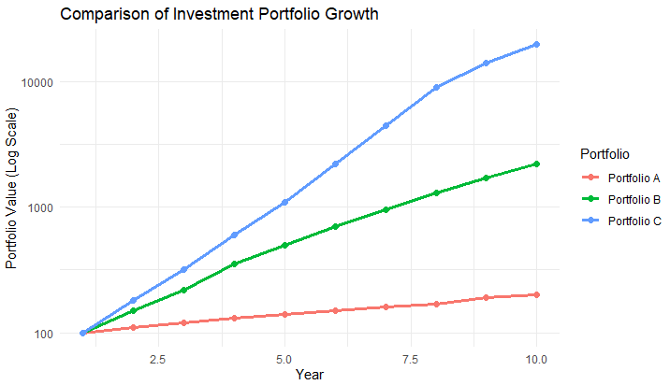
Problem 2 (10 Marks)
Scenario: You have a dataset of 200 employees with Department (nominal), Job Level (ordinal: Junior,
Mid, Senior, Lead), and Annual Salary (numeric).
a) Design a visualization that shows the salary distribution across job levels. Which chart type and aesthetic
mappings would you choose, and why?
b) How would you additionally encode Department in the same chart without overcrowding it?
c) Justify your choice of scale (position, size, or color) for representing Salary specifically.

a) Design a visualization that shows the salary distribution across job levels. Which chart type and aesthetic mappings would you choose, and why?
- Chart Type: Box Plot
- Aesthetic Mappings:
  - X-axis: Job Level (Junior, Mid, Senior, Lead)
  - Y-axis: Annual Salary
  - Color (optional): Department
Justification:
A box plot is ideal for showing the distribution of salaries across different job levels. It displays the median, quartiles, spread, and potential outliers, making salary comparisons easy.

b) How would you additionally encode Department in the same chart without overcrowding it?
Encode Department using different colors for each department or use faceting (separate panels) by department. This keeps the visualization clear and avoids overlapping too many elements.

c) Justify your choice of scale (position, size, or color) for representing Salary specifically.
Use Position (Y-axis) to represent Annual Salary.
Justification:
Position on a common axis is the most accurate and easiest way to compare numerical values like salary. Using size or color for salary would make exact comparisons more difficult, whereas position allows viewers to quickly identify differences in salary across job levels.

Conclusion:

